English Grammar – W/H Questions
English | Portuguese | Example(s)
where | onde | Where is Peter?
when | quando | When is your birthday?
who | quem | Who is your teacher?
why | por que | Why are your clothes dirty?  Because ……..
how | como | How are you?
how old | quantos anos | How old are you?
how many  (countable) | quantos | How many children do you have?
how much  (uncountable) | quanto | How much is this, please?  How much coffee do you want?
how often | com qual frequência | How often do you go to the gym?
how far | qual distância | How far is the hotel from here?
how long | quanto tempo | How long is the English class?
what  (opções infinitas) | o que | What is your name?
which  (opções limitadas) | qual | Which football team do you support?
whose | de quem | Whose is this book?
Suggested video: https://www.youtube.com/shorts/9tug1cSZm0E (1 min)
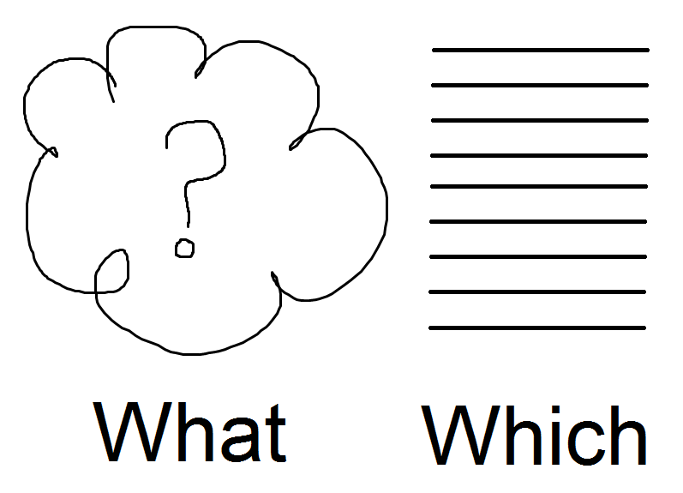
(opções infinitas) (opções limitadas)

Suggested video: https://www.youtube.com/watch?v=ToASm7lW1t8 (1 min)

Exercise 1. Reorganize as palavras para formar perguntas:
1. name your dog's is what ? _________________________________________________
2. do church when you to go ? _________________________________________________
3. is how shirt much this ? _________________________________________________
4. Japanese do study you why ? _________________________________________________
5. play when football do you ? _________________________________________________
6. old is your how dog ? _________________________________________________
7. pen is this whose ? _________________________________________________
8. like do you cake which ? _________________________________________________
9. you have how kids do many ? _________________________________________________
10. often you how do eat out ? _________________________________________________

Exercise 2. Responda as seguintes perguntas:
1. Where do you live? ____________________________________
2. What colors do you like? ____________________________________
3. Which languages do you speak? ____________________________________
4. When is your birthday? ____________________________________
5. How do you go to work? ____________________________________
6. How old is your partner? ____________________________________
7. Why are you learning English? Because ____________________________
8. How often do you go to the beach? ____________________________________
9. Who is the president of the USA? ____________________________________
10. How many bedrooms are there in your house? ___________________________
11. How much is a bus fare? ____________________________________
12. Whose is this book? ____________________________________

